Lesson Plan
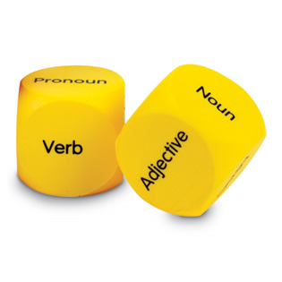

Unit Topic or Theme
English Language Arts
Grade
3rd Grade

Lesson Topic or Theme
Parts of Speech

Lesson Objectives:
The student will be able to:
- Identify parts of speech such as noun, adjective, verb, adverb, preposition, conjunction and interjection.
- Match the correct part of speech with its correct definition.
- Be able to correctly fill in an example of a part of speech in an incomplete sentence.

Instructional Technique:
An online quiz
A handout to fill out after the quiz

Instruction Materials:
A computer.
http://www.westfield.ma.edu/personalpages/draker/edcom/final/webprojects/sp14/partsspeed/index.html
Follow-up worksheet to be handed out in during class.

Theoretical Perspective:
Important because this lesson informs them on the parts of speech and how they can be used in a sentence. It also allows them to use their knowledge of parts of speech to fill in words in a sentence.

Procedure:
- Teachers and students will have a conversation about the beginning of their lesson about parts of speech. The teacher will inform the students that this online quiz and handout are just to see what they know and understand.
- Students will go to their designated seats where the quiz will already be pulled up on the computer. Students will individually complete the quiz to the best of their ability. The teacher will walk around and help those who need it. Once the students finish their online quiz, they will shut their computers and receive a handout from the teacher.
- After the students are done with their handouts, we will come together as a group and talk about what the students did and did not understand about parts of speech. As a class we will grade the handout so the students can get immediate feedback on how they are doing with parts of speech. This will be the basis for the rest of our lesson on parts of speech.
- The teacher will adapt for different learners by walking around and helping out and explaining things in more detail. The teacher will also let a few students work in pairs on the handout if necessary based on their abilities.

Evaluation:

a. The student will be able to:
- Identify parts of speech such as noun, adjective, verb, adverb, preposition, conjunction and interjection by correctly answering 5 out of 7 questions on the online quiz.
- Match the part of speech with its definition by correctly matching 3 out of 4 matching questions on the handout.
- Be able to correctly fill in an example of a part of speech in an incomplete sentence by correctly completing 3 out of 4 incomplete sentences on the handout.
b. Because students are at different reading levels, it will make this lesson difficult for those who struggle with reading.

