Educ. 0396 Jackie McHugh
Final Project Lesson Plan 04.20.13

- Unit Topic or Theme: Science
- Grade: Grade 4
* * * * * * * * * * * * * * * * *
- Lesson Topic or Theme: Solar System
- Lesson Objectives:
  - Students will be able to put the planets in order from the sun
  - Students will be able to identify each planet based on the material learned in class
    - Hottest and coldest planet (Mercury and Venus)
    - Which planet has life (Earth)
    - Which planets have rings (Jupiter, Saturn, Uranus, Neptune)
    - Nickname of Mars (Red Planet)
    - Jupiter’s red spot
    - Uranus is on its side
  - Students will be able to understand the sun is a star and Pluto is a dwarf planet
- Instructional Technique:
  - Group Work
  - Discussion & Lecture
  - Individual Work
- Instructional Materials: (copies of worksheets found at end of lesson plan)
  - Worksheet (From All Kids Network)
  - Informational Worksheet (Made by J.J. Kelto; edited by me)
  - Website created by teacher with worksheet

Works Cited
Kelto, J.J. . "Introduction to the Nine Planets in our Solar System." Kelto Link Page. 3
Dec. 2004. Web. 20 Apr. 2013. <http://ellerbruch.nmu.edu/classes/CS255F04/
cs255students/jbowerman/P11/SpacePDF>.
"Solar System Worksheet." All Kids Network. Web. 20 Apr. 2013.
<http://www.allkidsnetwork.com/worksheets/space/solar-system-worksheet.asp>.

- Theoretical Perspective: It is important for students to know about their surroundings. They should know that earth is just one of the eight planets orbiting our sun. They need to also be aware that knowledge of outer space is constantly changing.
- Procedure:
A. Introductory Activity (if applicable)
- Students will be seated at their desks, which are arranged in four groups of four. Each group will have two photographs, each of a planet. The groups will have two big sheets of lined paper. Their job is to describe the planets on the pieces of paper.
- After, the teacher will tape each description and picture on the board and the students will discuss them to familiarize themselves with each planet. The descriptions and pictures will be taped in the correct order that the planets actually are in space starting from the sun.
B. Step-by-step (descriptive outline)
- The students will be given the planet fact sheet. It will be read by the teacher and the students will follow along. Each student will have a highlighter. The teacher will let the students know what to highlight on the sheet, indicating what facts they should know about each planet.
- The students will be given the “Our Solar System” worksheet. Students can work on this worksheet in their table groups, but each student will color and fill in his/her worksheet.
- Each student will go on the website made by the teacher and fill out the corresponding worksheet as they go through the site. The filled out worksheet will be turned into the teacher after as an assessment tool.
C. Closure
- The room will be separated into eight sections, each assigned to a planet. The students go to the section assigned to the planet they would choose to go to if they could. Each group of students will discuss with one another why they would choose to visit this planet, and then present their reasons to the class.
D. Adaptations for different learners
- There will be pictures and colors on the website to help with struggling readers and English Language Learners.
- If an English Language Learner needs help going through the website and worksheet, the teacher will be more than happy to help them understand what is being asked.
- For people who struggle with reading, the external links on the website to more information on the solar system are videos. This helps provide a visual as well. This can help ELLs and visual learners.
E. Homework
- Draw the sun, followed by the planets in the correct order. However, instead of actually drawing the planets, draw objects (such as a basketball, a tennis ball, etc.) to show their differences in sizes. This does not need to be perfect. As long as you have the right idea, you did it correct!
- Evaluation:
A. How/ when will you determine if you have met your objectives?
  - Students will be able to put the planets in order from the sun
    - This will be determined by one of the questions on the website & worksheet. If the students write down the correct order of the planets, they will meet the guidelines for demonstrating their knowledge of the order of the planets.
  - Students will be able to identify each planet based on the material learned in class
    - The worksheet that the students fill out while on the website will determine if they can meet this objective. If they get the correct answers, they met the objective.
  - Students will be able to understand the sun is a star and Pluto is a dwarf planet
    - The worksheet that the students fill out while on the website will determine if they can meet this objective. If they get the correct answers to the questions involving this information, they met the objective.
B. Concerns or questions you have about teaching this lesson?
- Originally I was thinking about including a book on the solar system for the students to read, but I decided against it since the books I looked at had a lot of information about each of the planets. I feel like all of the information in the book would overwhelm the students, so I chose to use the planet fact sheet instead. I hope I made the right decision.

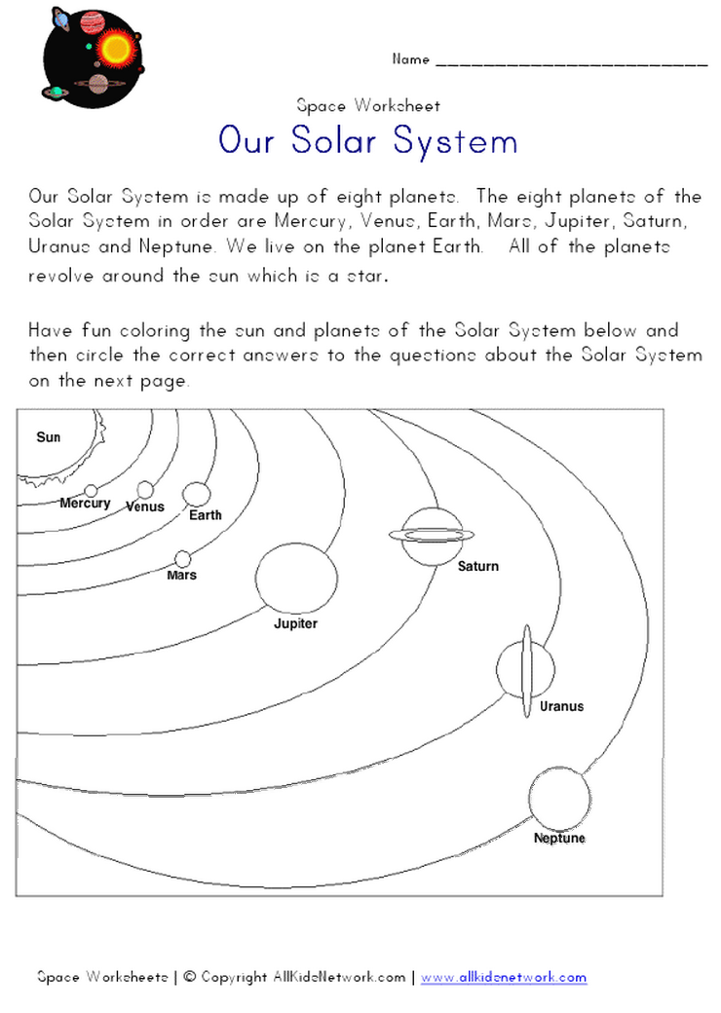
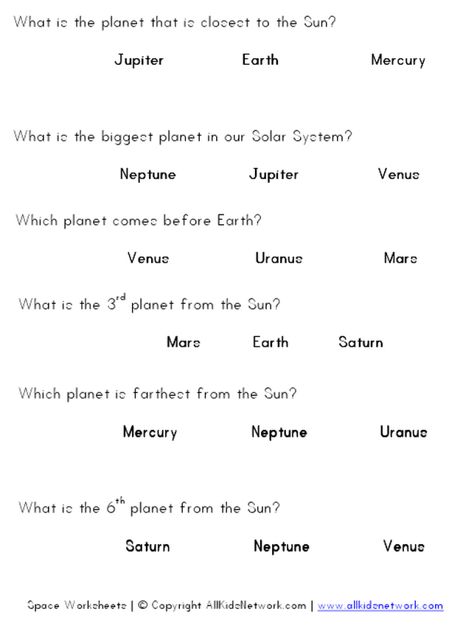
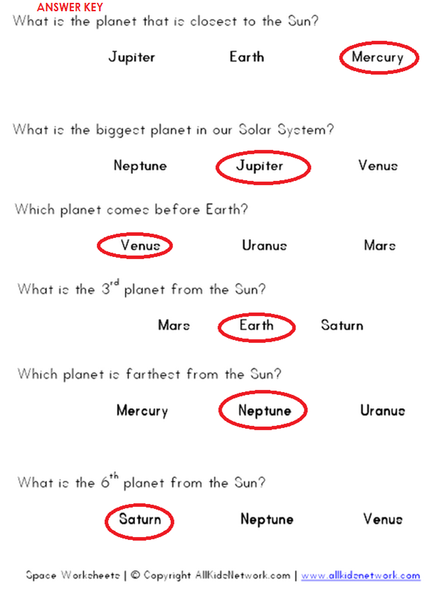
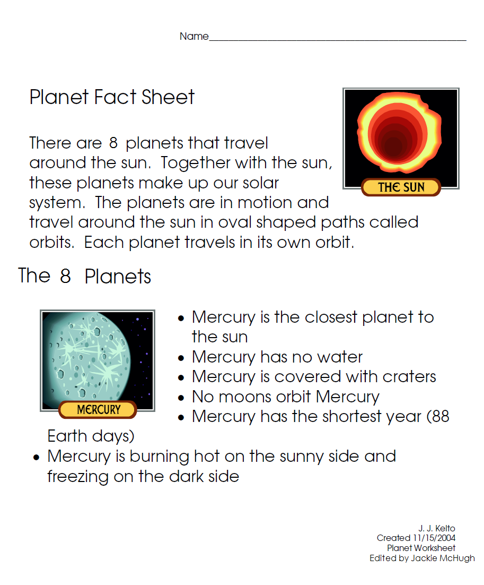
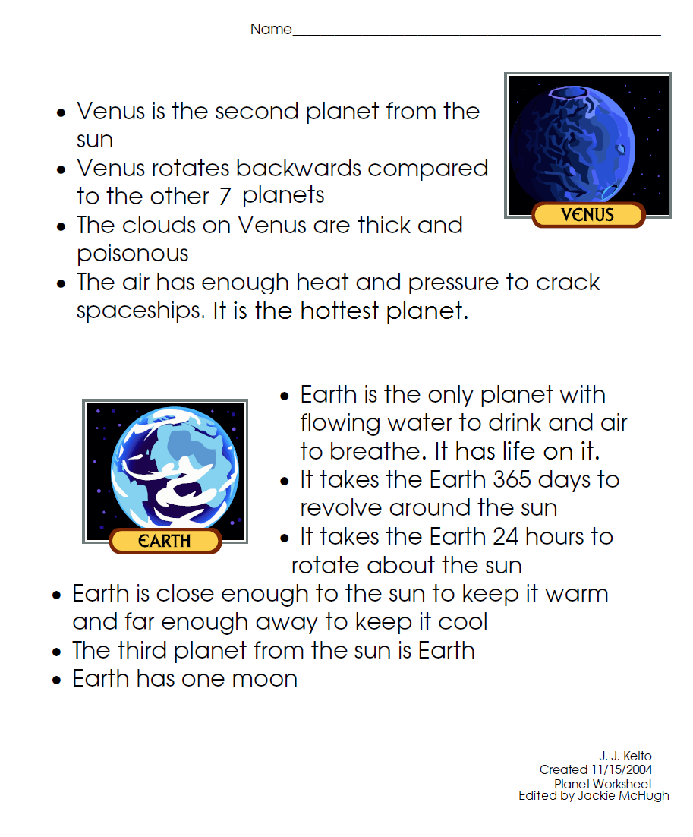

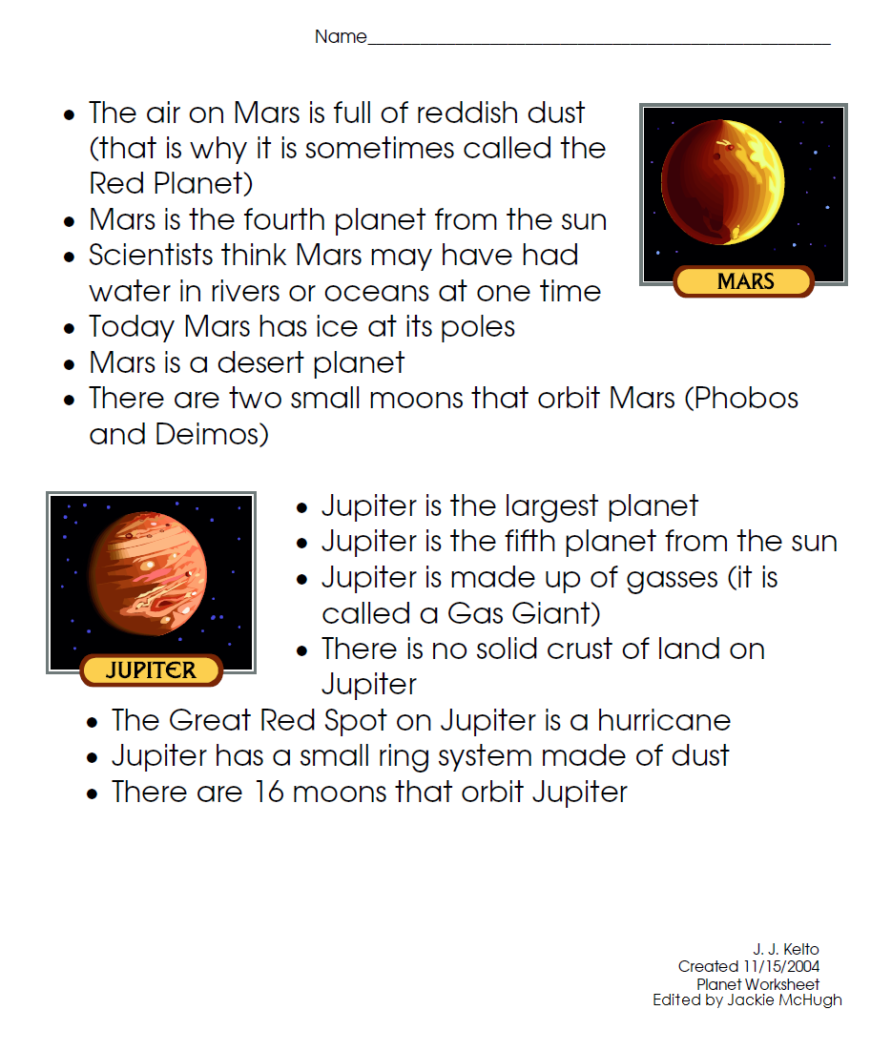

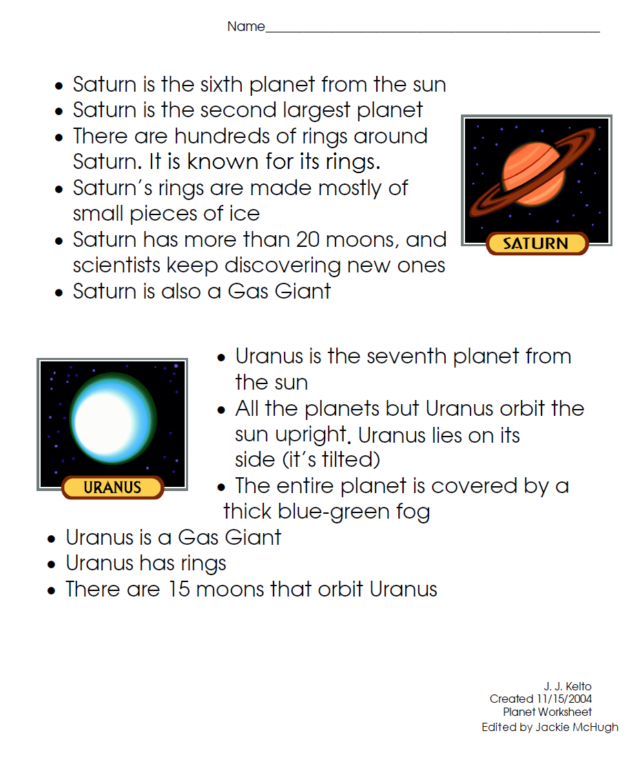

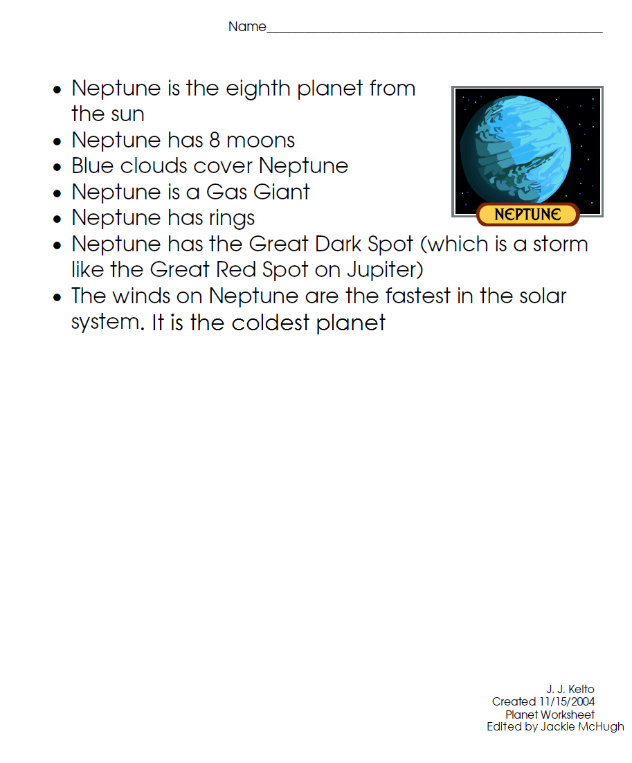

Name: ____________________________________________ Date: _____________
Tour of Our Solar System
Directions: After the tour, you will give this information to each tourist that was on your tour. Your job is to fill out each question with the correct information.

- The planet closest to the sun is _________________.
- There are ____ planets in our solar system, not including dwarf planets.
- Pluto is considered a ________________.
- The order of the planets starting closest from the sun is: _________________________________________________________________________________________________________________________________________________.
- The hottest planet is _______________.
- The coldest planet in our solar system is ____________.
- The planet that currently supports life is _____________.
- The planet known as the “Red Planet” is ___________.
- The planet with the big red spot on it is _____________. The spot is due to a ____________.
- ___________ is the largest planet. ____________ is the second largest planet.
- The planets that have at least one ring are ____________, ____________, ___________, and ____________.
- The planet with the most rings is ______________.
- The planet that is tilted on its side is _____________.
- The sun is a _________.

Name: Answer Key
Tour of Our Solar System
- The planet closest to the sun is Mercury.
- There are 8 planets in our solar system, not including dwarf planets.
- Pluto is considered a dwarf planet.
- The order of the planets starting closest from the sun is: Mercury, Venus, Earth, Mars, Jupiter, Saturn, Uranus, Neptune
- The hottest planet is Venus.
- The coldest planet in our solar system is Neptune.
- The planet that currently supports life is Earth.
- The planet known as the “Red Planet” is Mars.
- The planet with the big red spot on it is Jupiter. The spot is due to a storm.
- Jupiter is the largest planet. Saturn is the second largest planet.
- The planets that have at least one ring are Jupiter, Saturn, Uranus, and Neptune.
- The planet with the most rings is Saturn.
- The planet that is tilted on its side is Uranus.
- The sun is a star.

