Group Members:

Date:

**Directions:** Label each state on the blank map of the U.S. below. Then write the capital and one fact for each state in the area provided.

[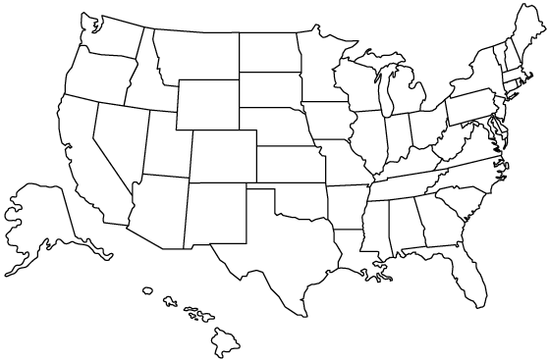](http://www.google.com/url?sa=i&rct=j&q=blank+map+of+the+united+states&source=images&cd=&cad=rja&docid=iYXYeMcx9Cxj4M&tbnid=54HdaCbMcgZvIM:&ved=0CAUQjRw&url=http%3A%2F%2Fwww.abington.k12.pa.us%2Fteachers%2Fduraba%2FMaps.htm&ei=g6yBUfveEOfg0gH4-oCgBg&bvm=bv.45921128,d.dmQ&psig=AFQjCNEidSZMMZnOslzwc635trBlOHDF4w&ust=1367539192033632)

**The 50 States:**

1. Alabama
   1. Capital:
   2. Fact:
2. Alaska
   1. Capital:
   2. Fact:
3. Arizona
   1. Capital:
   2. Fact:
4. Arkansas
   1. Capital:
   2. Fact:
5. California
   1. Capital:
   2. Fact:
6. Colorado
   1. Capital:
   2. Fact:
7. Connecticut
   1. Capital:
   2. Fact:
8. Delaware
   1. Capital:
   2. Fact:
9. Florida
   1. Capital:
   2. Fact:
10. Georgia
    1. Capital:
    2. Fact:
11. Hawaii
    1. Capital:
    2. Fact:
12. Idaho
    1. Capital:
    2. Fact:
13. Illinois
    1. Capital:
    2. Fact:
14. Indiana
    1. Capital:
    2. Fact:
15. Iowa
    1. Capital:
    2. Fact:
16. Kansas
    1. Capital:
    2. Fact:
17. Kentucky
    1. Capital:
    2. Fact:
18. Louisiana
    1. Capital:
    2. Fact:
19. Maine
    1. Capital:
    2. Fact:
20. Maryland
    1. Capital:
    2. Fact:
21. Massachusetts
    1. Capital:
    2. Fact:
22. Michigan
    1. Capital:
    2. Fact:
23. Minnesota
    1. Capital:
    2. Fact:
24. Mississippi
    1. Capital:
    2. Fact:
25. Missouri
    1. Capital:
    2. Fact:
26. Montana
    1. Capital:
    2. Fact:
27. Nebraska
    1. Capital:
    2. Fact:
28. Nevada
    1. Capital:
    2. Fact:
29. New Hampshire
    1. Capital:
    2. Fact:
30. New Jersey
    1. Capital:
    2. Fact:
31. New Mexico
    1. Capital:
    2. Fact:
32. New York
    1. Capital:
    2. Fact:
33. North Carolina
    1. Capital:
    2. Fact:
34. North Dakota
    1. Capital:
    2. Fact:
35. Ohio
    1. Capital:
    2. Fact:
36. Oklahoma
    1. Capital:
    2. Fact:
37. Oregon
    1. Capital:
    2. Fact:
38. Pennsylvania
    1. Capital:
    2. Fact:
39. Rhode Island
    1. Capital:
    2. Fact:
40. South Carolina
    1. Capital:
    2. Fact:
41. South Dakota
    1. Capital:
    2. Fact:
42. Tennessee
    1. Capital:
    2. Fact:
43. Texas
    1. Capital:
    2. Fact:
44. Utah
    1. Capital:
    2. Fact:
45. Vermont
    1. Capital:
    2. Fact:
46. Virginia
    1. Capital:
    2. Fact:
47. Washington
    1. Capital:
    2. Fact:
48. West Virginia
    1. Capital:
    2. Fact:
49. Wisconsin
    1. Capital:
    2. Fact:
50. Wyoming
    1. Capital:
    2. Fact: