Lesson Plan Outline

Callie Marmo & Alyssia Cummings

- Unit Topic or Theme: Human Anatomy
- Grade: 5th
* * * * * * * * * * * * * * * * *
- Lesson Topic or Theme: The Digestive System
- Lesson Objectives: The student will learn each part of the digestive system and be able to travel through Mr. Apple’s digestive process successfully and correctly complete the worksheet.
- Instructional Technique: This lesson is to be done individually
- Instructional Materials: In order to complete this lesson, the students will need scissors, coloring materials, glue sticks, and a pencil to label each part of the digestive system.
- Theoretical Perspective: It is important for our students to learn about the digestive system because it teaches them about their bodies and how they work.

- Procedure:
- Introductory Activity
Collectively, the class will see the anatomy of the human body. The teachers will specifically label and point out each step along the digestive system.

- Step-by-step
  - Introduction to human anatomy
  - Attempt and correct completion of Mr. Apple’s journey through the digestive system via the webpage
  - Color and cut out each part of the digestive system
  - Paste each part of the digestive system on the outline of the human body
  - Label each step along the digestive tract with help from the descriptions on the side

- Closure
The students will review and self correct the completed worksheets while following along with the teacher. The students will make sure that their answers are correct, and if not, change them to the correct answers.

- Adaptations for different learners
If there was a child in the classroom that was a non-native speaker, we would find the terms and descriptions in their native language and teach the human anatomy to the child individually using both languages (native and English).
- Evaluation:
- How/ when will you determine if you have met your objectives?
The teacher will collect and correct the worksheets to determine whether or not the students understand the human digestive system.

- Concerns or questions you have about teaching this lesson?
One concern that we have about this lesson would be if the website was not working for every student due to technical difficulties.

Name________________________________________ Date____________________________
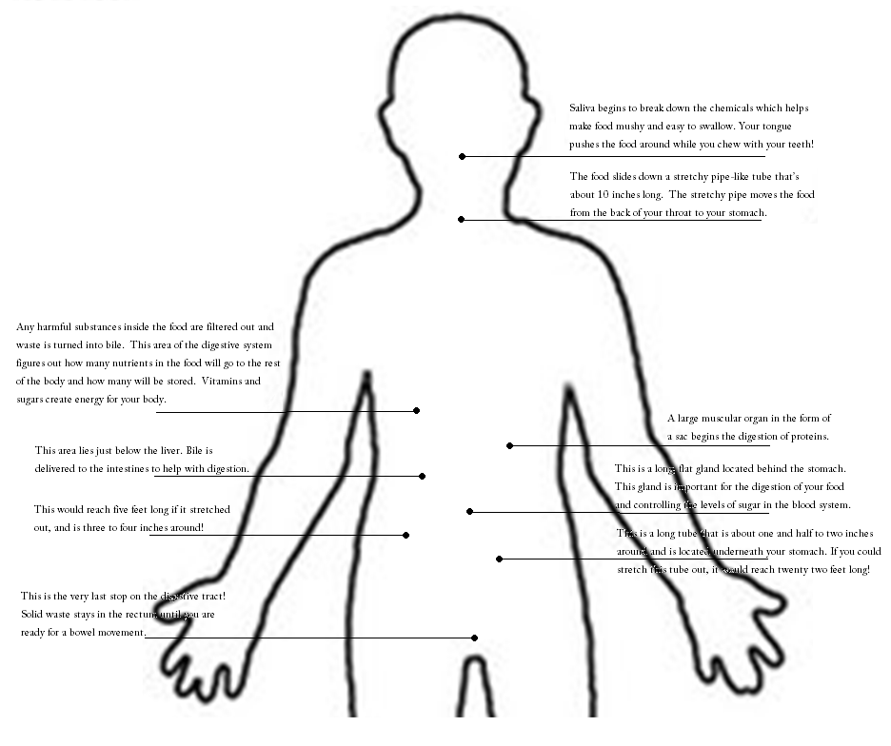
Digestive System Diagram

