Name___________________________________ Date________________

Label the following countries on the map of South America:

**-Argentina -Colombia -Ecuador**

**-Bolivia -Paraguay -Peru**

**-Brazil -Uruguay -Venezuela**

**-Chile**

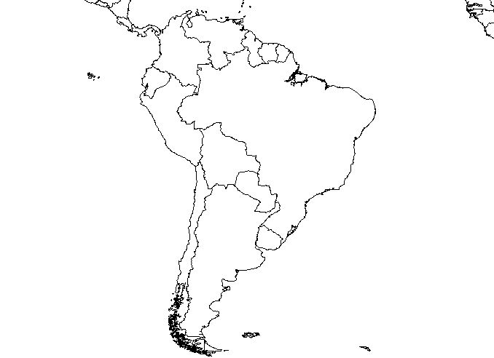

BONUS: On a separate piece of paper, provide the capital of country that is listed above.