Name: _____________________________ Date: _______________

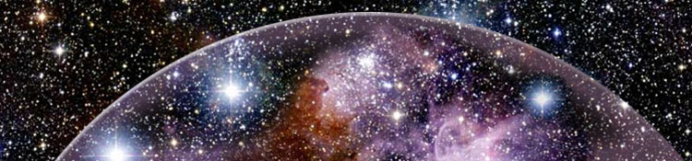

For the past few days we have been learning about our Solar System.
Now it is time to test what we have learned.
This worksheet will be completed while doing the online quiz activity.
This worksheet will help you with next activity. Please be specific

For this sections, list up to three facts that you have learned about this planet or object in the Solar System:
- Sirius:

- The Sun

- Asteroids

- Jupiter

- Neptune

- Mercury

- Venus

- Mars

- Earth’s Moon

- Uranus

- Saturn

- Earth

- Pluto

- Meteor

- Black hole

- Comet

Which objects did you get correct the first time?
1.
2.
3.
4.
5.
6.
7.
8.
9.
10.

Which objects did you need more than one attempt to get correct?
1.
2.
3.
4.
5.
6.
7.
8.
9.
10.

