Name: ____________________________ Date: ___________________

A Volcanic Eruption

Fill in Notes

**Directions:**

Use the website, <http://www.iknowthat.com/ScienceIllustrations/volcano/science_desk.swf> , to fill in the note sheet.

1. Label the parts of the volcano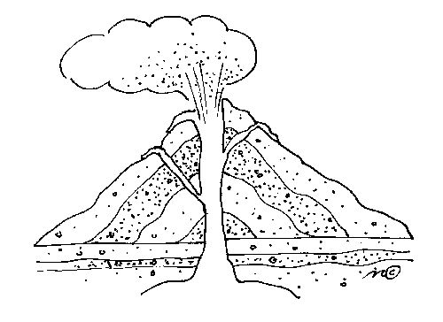.

______________

A ______________ is a crack in the _______________ crust through which ___________, pieces of _________ and hot __________ erupt. A __________ is often a mountain that has formed from repeated _____________.

_____________

A ______________ is an opening through which ____________ and other volcanic material erupts. A ______________ has a main ___________ and may also have smaller side vents, called ________________.

_______________

The ___________ is the ___________________ layer of the earth. It is about ____ miles thick under the continents and about ____ miles thick under the oceans.

_______________

_____________ is a mixture of melted ___________ and ___________ below the surface of the earth.

**________________ Chamber**

A __________________ chamber is the space beneath a _________________ where _______________ collects and pools.

1. Fill in the four steps on how a volcano erupts.
   1. Beneath the ____________________, molten _________________ rock filled with _______________________ collects in the ___________________ chamber.
   2. Magma pushes through ________________ in the Earth’s ________________ and rises up into the ____________________ vent. _________________ is building up in the mountain.
   3. The _____________________ becomes so great that the _______________________________ blows off! Ash and ______________ shoot high into the air forming a big _______________. Lava flows from the _____________ and its branches.
   4. After the _____________________, the volcano looks different. Now there is a ___________ at its top. Over time, __________________ might build up again and cause another eruption.
2. Types of Volcanoes

1.______________________

2.______________________

3.______________________

4.______________________

1. Additional Information:
   1. Lava can reach temperatures of _____________ to ______________.
   2. About half of the world’s active volcanoes are located around the __________________ Ocean. This zone is called the ________________ of ______________.
   3. In 1935, Charles Richter invented a system for measuring the size of earthquakes called the ______________ ______________. Tracking earthquakes activity is important for ____________________ volcanoes.

**Bonus Question:**

Scientists have discovered volcanoes on ________________ and _______________.