Name: ______________________

1) What is a tornado?

A) A tornado is a violent rotating column of air extending from a thunderstorm to the ground.

B) A thunderstorm

C) A hailstorm

D) A storm from Canada

2) How do tornadoes form?

A) when smoky, churning clouds form

B) when wall clouds produce rain

C) when warm, moist air meets cool, dry air

D) when a gustnado forms in California

3) A ­­­_________ is a very weak tornado that is not associated with a wall cloud or a mesocyclone. It is the land equivalent of a waterspout.

A) dust devil

B) hail

C) gustnado

D) landspout

4) Shade in tornado alley.

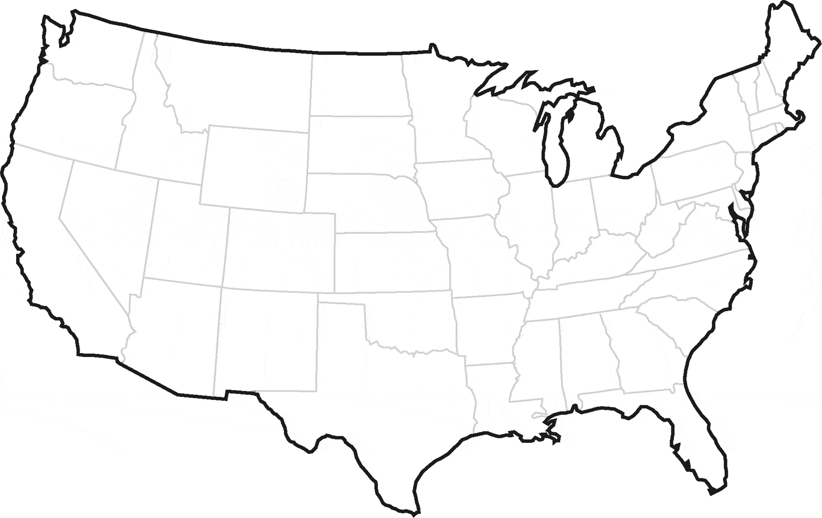

5) What is the largest hailstone recorded in the United States and where did it fall?

A) 2 inches, half a pound, my backyard

B) 8 inches, 2 pounds, Vivian, South Dakota

C) 23 inches, 2 pounds, North Dakota

D) 2 inches, 8 pounds, Vivian, South Dakota

6) Tornadoes are most likely to occur ___________________.

A) in January

B) in Alaska

C) At any time of the year and any time of the day

D) Only in the winter

7) “A tornado is either on the ground or has been detected by Doppler radar. Seek shelter immediately!” What does this describe?

A) Tornado warning

B) Tornado watch

C) Tornado alley

D) Fujita Scale

8) Fill in the chart:

|  |  |  |
| --- | --- | --- |
| SCALE | WIND SPEED | POSSIBLE DAMAGE |
| F0 |  | Light damage: Branches broken off trees; minor roof damage |
|  | 73-112 mph | Moderate damage: Trees snapped; mobile home pushed off foundations; roofs damaged |
| F2 | 113-157 mph |  |
|  | 158-206 mph | Severe damage: Trains overturned; cars lifted off the ground; strong built homes have outside walls blown away |
| F4 |  | Devastating damage: Houses leveled leaving piles of debris; cars thrown 300 yards or more in the air |
|  | 261-318 mph |  |

9) A _____________ is a rotating vortex of air within a supercell thunderstorm. They do not always produce tornadoes.

A) Supercell

B) Mesocyclone

C) Microburst

D) Wall Cloud

10) Name 1 thing you should do to stay safe in a tornado.

_____________________________________________________________.